如何用SignalR將Windows Form轉成Web Page

假設有一個算目錄大小的程式，要轉成網頁。

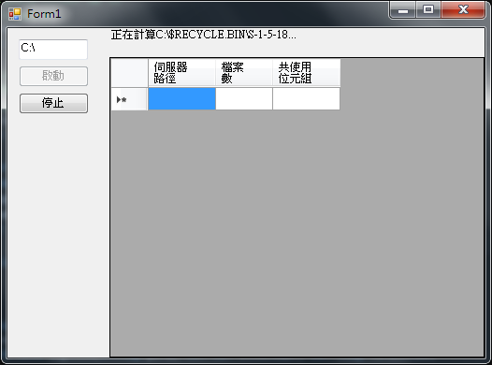

Step 1: 將Windows Form的功能介面抽出來為ICountFolders.cs及CountFolders.cs，再由ASP.NET Web Application for Web API範本新增專案，並加入空的Web API 2範本WebPageController.cs裡面包含Authorized、StartRun、StopRun等Web API。在Web.config加入<authentication mode="Forms" />之後，可在Web API裡面加入有關權限的程式碼，並測試之。

Step 2: 在WebPage專案由NuGet新增SignalR (2.2.0)，且由NuGet更新全部元件，並在專案檔按右鍵，新增OWIN Startup class 及 SignalR Hub Class (SignalR Hub Class可放在Hubs目錄)，在OWIN Startup class加入app.MapSignalR();程式碼，並加入測試網頁login.html、index.html及所對應的login.js、index.js(記得由SignalR Hub呼叫Server端method要用小寫，如hub.server.hello())，測試SignalR。

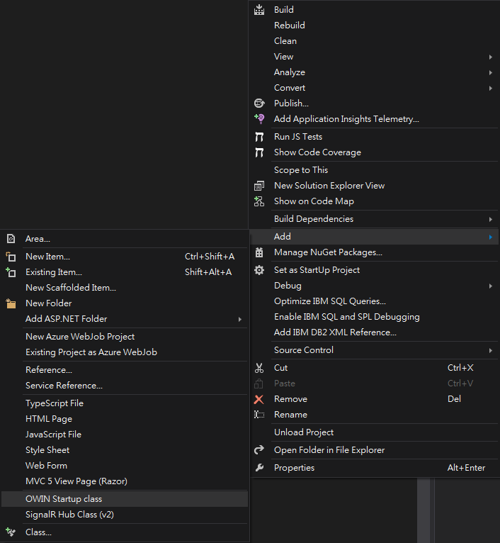

Step 3: 從WinForm複製ICountFolders.cs及CountFolders.cs到WebPage (包成 .dll再參考進來也可以)，並加入兩個屬性string ConnectionId及DateTime StartTime，在WebPage新增CountFoldersTicker類別，填入建構並記錄CountFolders物件的程式碼，並包含延遲產生的靜態CountFoldersTicker執行個體，然後在SignalR Hub Class加入註冊並產生CountFolders物件的程式碼，修改index.js，並測試之。

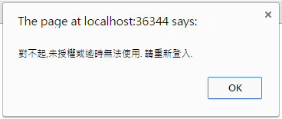

(若沒有通認login驗證，則會出現此訊息)

Step 4: 在放Web API程式碼WebPageController.cs，加入連結CountFoldersTicker的程式碼，並修改index.js加入使用Web API的程式碼，測試之。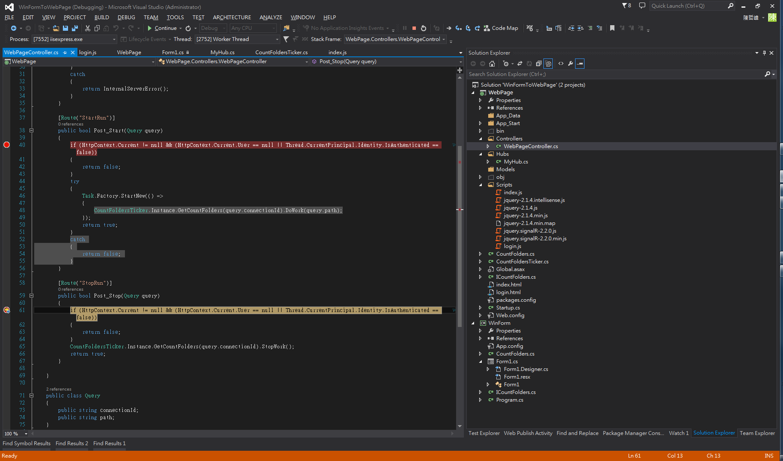

Step 5: 在index.html加入UI，並在index.js加入相關UI的程式碼後完成。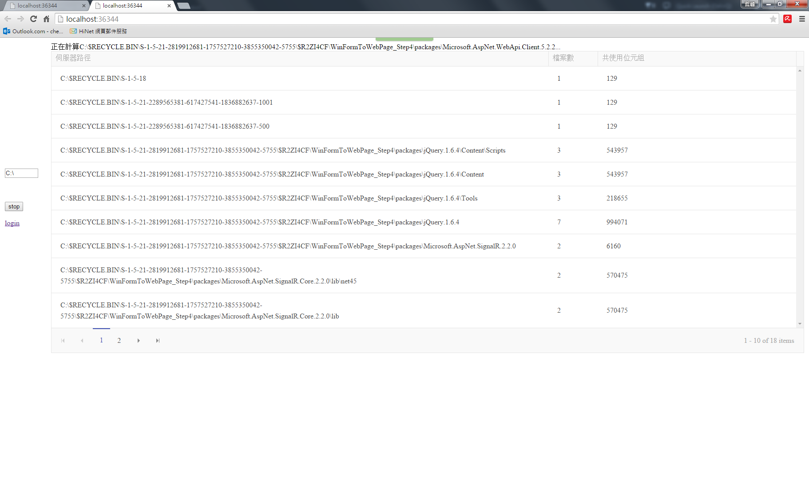

<http://stackoverflow.com/questions/21277531/signalr-javascript-client-on-mobile-devices>

<http://www.asp.net/signalr/overview/getting-started/tutorial-getting-started-with-signalr>

http://horacerobot.blogspot.tw/2010/08/csharp-system-lazy.html

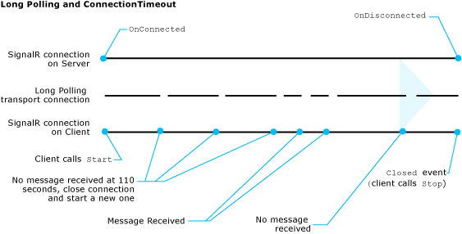

1. Client calls Start
2. Server OnConnected
3. Client calls Stop
4. Server OnDisconnected  
   OnDisconnected(bool stopCalled) => stopCalled == true
5. Client Closed event for 4

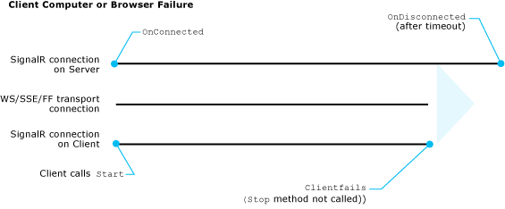

1. Client calls Start
2. Server OnConnected
3. Client failure
4. Server timeout
5. Server OnDisconnected  
   OnDisconnected(bool stopCalled) => stopCalled == false

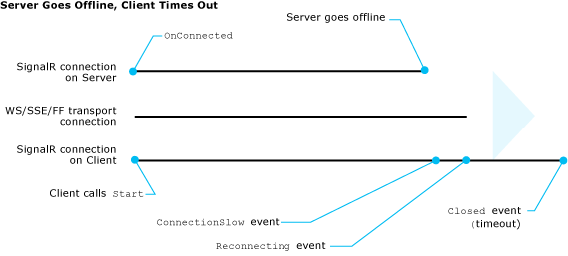

1. Client calls Start
2. Server OnConnected
3. Server Offline
4. Client ConnectionSlow event
5. Client Reconnecting event
6. Client timeout
7. Client Closed event

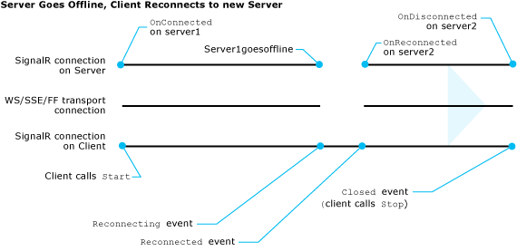

1. Client calls Start
2. Server1 OnConnected
3. Server1 Offline
4. Client ConnectionSlow event
5. Client Reconnecting event
6. Server2 OnReconnected
7. Client Reconnected event for 6

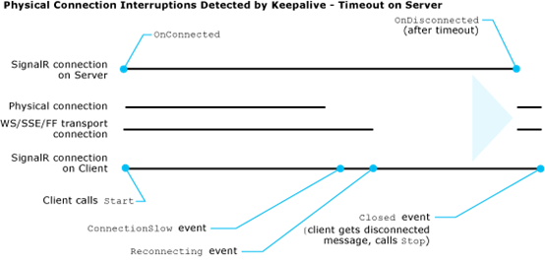

1. Client calls Start
2. Server OnConnected
3. Physical Connection Interruptions
4. Client ConnectionSlow event
5. Client Reconnecting event
6. Server timeout
7. Server OnDisconnected  
   OnDisconnected(bool stopCalled) => stopCalled == false
8. Physical Connection Recovers
9. Client Closed event for 7

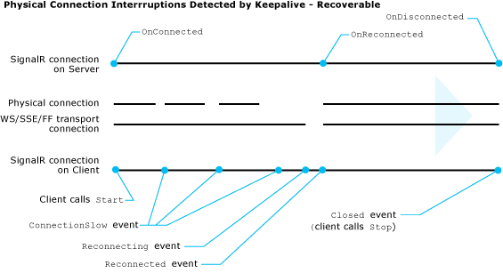

1. Client calls Start
2. Server OnConnected
3. Physical Connection is intermittent
4. Client ConnectionSlow event
5. Physical Connection Interruptions
6. Client Reconnecting event
7. Physical Connection Recovers
8. Server OnReconnected
9. Client Reconnected event for 8

How to persist group membership?

How to retain information about users and their connections?

How to test and debug SignalR applications?

How to maximize the performance of SignalR applications?

How to deploy and host SignalR applications?

About Programming the server side of the ASP.NET SignalR

How to register SignalR middleware?

How to create and use Hub classes?

How to define methods in the Hub class that clients can call?

How to call client methods from the Hub class?

How to select which clients will receive the RPC (Remote Procedure Call)?

How to use a string variable as the method name?

How to manage group membership from the Hub class?

How to handle connection lifetime events in the Hub class?

How to get information about the client from the Context property?

How to pass state between clients and the Hub class?

How to handle errors in the Hub class?

How to enable tracing?

How to call client methods and manage groups from outside the Hub class?

How to customize the Hubs pipeline?

About The SignalR Hubs API enables you to make remote procedure calls (RPCs) from a server to connected javascript clients and from javascript clients to the server.

How to reference the dynamically generated proxy?

How to create a physical file for the SignalR generated proxy?

How to establish a connection?

How to establish a cross-domain connection?

How to specify query string parameters?

How to specify the transport method?

How to get a proxy for a Hub class?

How to define methods on the client that the server can call?

How to call server methods from the client?

How to handle connection lifetime events?

How to handle errors?

How to enable client-side logging?

About The SignalR Hubs API enables you to make remote procedure calls (RPCs) from a server to connected .net clients and from .net clients to the server.

## How to establish a connection?

## How to configure the connection?

## How to specify the transport method?

## How to specify HTTP headers?

## How to specify client certificates?

## How to create the Hub proxy?

## How to define methods on the client that the server can call?

## How to call server methods from the client?

## How to handle connection lifetime events?

## How to handle errors?

## How to enable client-side logging?

About You can handle the SignalR Connected, Reconnected, and Disconnected events on server, and handle the ConnectionSlow, Reconnecting, Reconnected, and Closed on client.

How to change timeout and keepalive settings?

How to notify the user about disconnections?

How to continuously reconnect?

How to disconnect a client in server code?

How to detecting the reason for a disconnection?